1. What are three conclusions we can make about Kickstarter campaigns given the provided data?

* The overall worldwide parent category chart shows the Theater parent category had the largest number of successes (see Chart below). It also had the largest number of failures in contrast with other Kickstarter categories. Also noted that the music category has a larger success to failure ratio than any other parent categories.

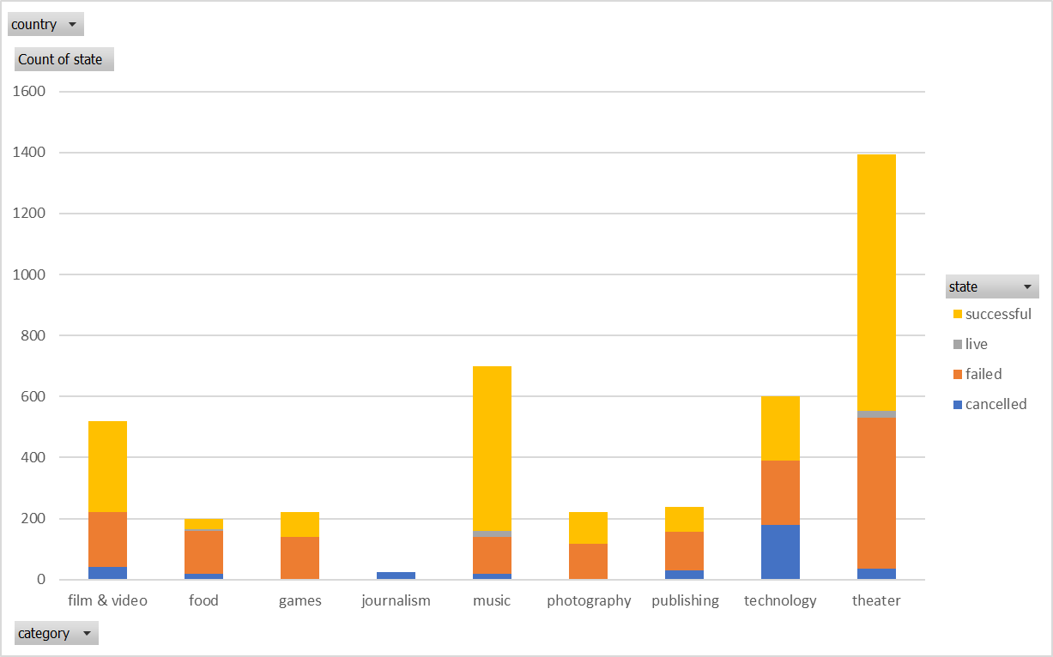

* Of all the sub-categories worldwide, plays accounted for the most successes and also the most failures (see Chart below). However, the subcategories: hardware, indie rock, rock and video documentaries had high success rates.

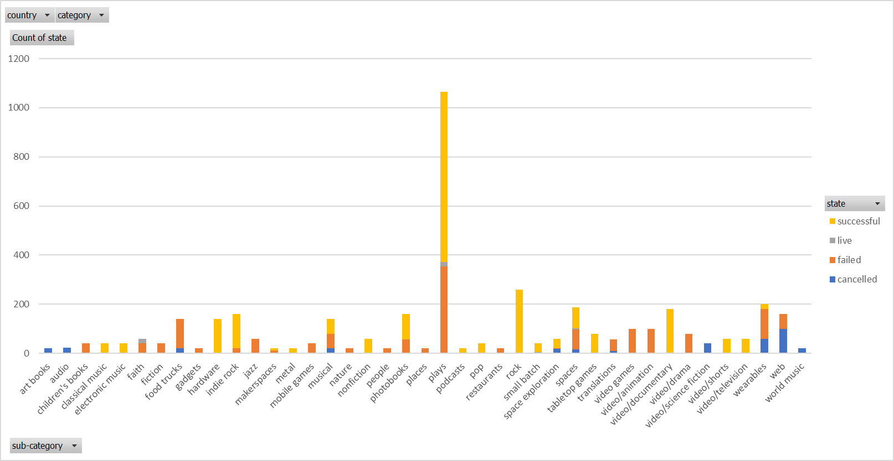

* The Chart below seems to illustrate that the third and fourth quarter of the year launches are showing a narrower difference between success and failure.

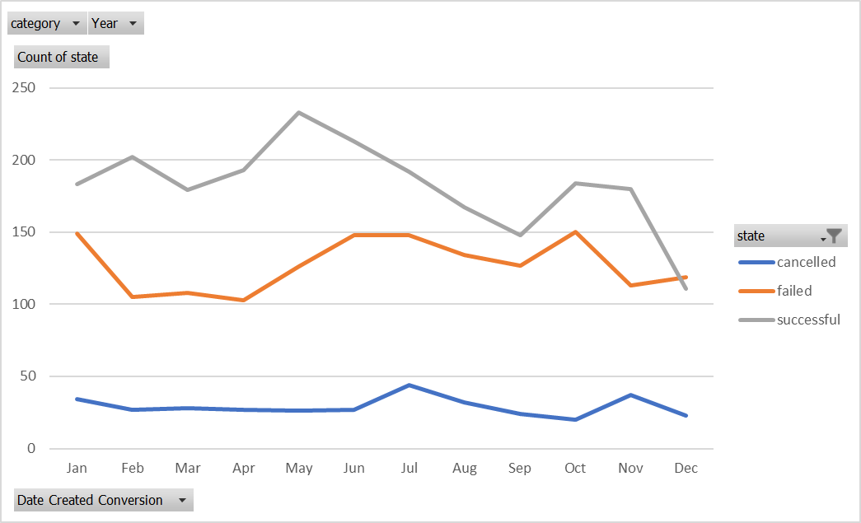

2. What are some of the limitations of this dataset?

* The goal values are all listed in different currencies. Only after the conversion, could you compare the relative value of the goals for the different categories and countries.
* The dates were listed in a unix timestamp format that is not interpretable – unless advised what those numbers meant.
* Not sure what ‘staff_pick’ nor spotlight_mean?
* It would be useful to know from which state or regions in the countries listed, did the proportion of donators came from to further narrow down the correlation between donators and kickstarter projects.

3. What are some other possible tables/graphs that we could create?

* The amount of money raised for each different country vs categories and sub-categories.
* The success ratio for the parent categories and sub-categories.
* Average donation for each category.
* How the donation period compares with the success rate.